浙江大学2009–2010学年 秋冬 学期
《汇编与接口》课程期末考试试卷
课程号： __________，开课学院：___计算机学院________
考试试卷：A卷√ B卷
考试形式：开卷√ 闭卷 允许带__1本书和1本资料__入场
考试日期： 2010 年 1 月 日,考试时间： 120 分钟
诚信考试，沉着应考，杜绝违纪。
考生姓名： 学号： 所属院系： _
题序 | 一 | 二 | 三 | 四 | 五 | 六 | 七 | 总 分
得分
评卷人

请把第一至第三题的答案写在本页的答题纸上，第一至第三题的的评分以答题纸上的答案为准。
一．（10 points）Mark T for correct instruction or description, mark F foe incorrect instruction or description.
1 | 2 | 3 | 4 | 5 | 6 | 7 | 8 | 9 | 10
二．(26 points) Please select your best choice for the following questions.
1 | 2 | 3 | 4 | 5 | 6 | 7 | 8 | 9 | 10
11 | 12 | 13
三．(6 points) The following program runs under 32-bit Visual C++ environment，Please choose the best answer.
（1） | （2） | （3） | （4） | （5） | （6）

- （10 points）Mark T for correct instruction or description, mark F for incorrect instruction or description.
F. MUL [SI]
T. ROL DWORD PTR [ECX], 2
F. MOV ES, 59A2H
T. JCXZ L2
F. IMUL WORD PTR [ESP]
F. ADD AX, [SP+2]
F. MOV AX, BX+DI
F. ADD [DI], [BX]
F. IN AX, 320H
T. POPAD

- (26 points)Please select the best choice for the following questions.
- In debug, ZR stands for “ZERO flag ZF is 1”. Which one stands for “Direction flag DF is 1” in debug?
A. FW B. DN C. UP D. DO
【答案】： B
- In real mode, SS=01H, DS=00H, BP=7EH, following memory data is shown in debug. After instruction “LES BX, [BP+4]’ is executed, ES and BX will be ___ _ .
0000:0080 72 10 A7 00 7C 10 A7 00-4F 03 80 05 8A 03 80 05
0000:0090 AD 06 14 02 A4 F0 00 F0-37 05 14 02 11 6D 00 C0
A. ES=0214H, BX= F0A4H B. ES=107CH, BX=00A7H
C. ES=F0A4H, BX=0214H D. ES=00A7H, BX=107C H
【答案】：C

- “BUF DW 1, 2, 3, 4” is equal to ___ _ in memory contents of BUF.
A. BUF DB 1,0, 2,0, 3, 0,4,0 B. BUF DB 0,1,0, 2,0, 3, 0,4
C. BUF DD 1000200H, 3000400H D. BUF DD 2000100H, 4000300H
【答案】：A

- MOV AX，73E2H
ADD AX，EA3EH, then OF and CF will be ___ _ .
A. OF=1 and CF=1 B. OF=1 and CF=0
C. OF=0 and CF=0 D. OF=0 and CF=1
【答案】：D

- Suppose that the offset address of variable DATA1 is 100H, which instruction will do “EAX ←-- EBX + 2*ESI + 70H” ?
A：LEA EAX, DATA1[EBX + 2*ESI – 90H]
B：MOV EAX, OFFSET [EBX + 2*ESI + 70H]
C：MOV EAX, EBX + 2*ESI + 70H
D：MOV EAX, OFFSET data1 + EBX + 2*ESI - 90H
【答案】： A

- MOV CX, 0FFFFH
STC
ADC CX,0
then CF and ZF be .
A. CF=0 and ZF=0 B. CF=0 and ZF=1
C. CF=1 and ZF=0 D. CF=1 and ZF=1
【答案】：D

- MOV EAX，260
MOV ECX，259
MUL CL then EAX＝ .
A. 6 B. 67340
C. 12 D. 780
【答案】：C

- Which ICW1 of 8259A selects cascade operation and edge triggered mode?
A：00011001B. B：00010010B.
C：00010001B. D：00010010B.
【答案】： C

- Which ICW2 sets IR2 of 8259A to interrupt vector FAH?
A：0F8H. B：0EAH.
C：7CH. D：0F0H.
【答案】： A

- Which ICW4 of 8259A selects normal EOI and non-buffered mode?
A：00011001B B：00000011B
C：00001001B D：00000001B
【答案】： D

- Which OCW1 of 8259A will mask interrupt from IR2 pin?
A：10000100B B：01000010B
C：00000100B D：00000010B
【答案】：C

- Which control word for 8254 sets counter 1 as a continuous square-wave generator?
A：01110100B B：01110110B
C：10110110B D：10111000B
【答案】：B

- Which control word for 8254 sets counter 2 as a continuous pulses generator?
A：01110101B B：01110100B
C：10110010B D：10110100B
【答案】：D

- (6 points) The following figure shows the detail converting 32-bit linear address to 32-bit physical address. Suppose CR3=3ab82H, 32-bit linear address=03a28fd4H, please fill blanks below.
(1). 10-bit “dir”= B, 10-bit “page”= B, 12-bit “offset”= H. Here “dir”， “page” and “offset” are 3 parts of linear address.
(2). The pointer A is a 30-bit page directory entry pointer, and it points to a 32-bit entry 0f0e0d0cH. The 32-bit pointer A1 is obtained by concatenate pointer A and 2-bit 00, then pointer A1 = H.
(3). The pointer B is a 30-bit page entry pointer, and it points to a 32-bit entry 11223344H. The 32-bit pointer B1 is obtained by concatenate pointer B and 2-bit 00, then pointer B1 = H;
(4). 32-bit physical address = H;

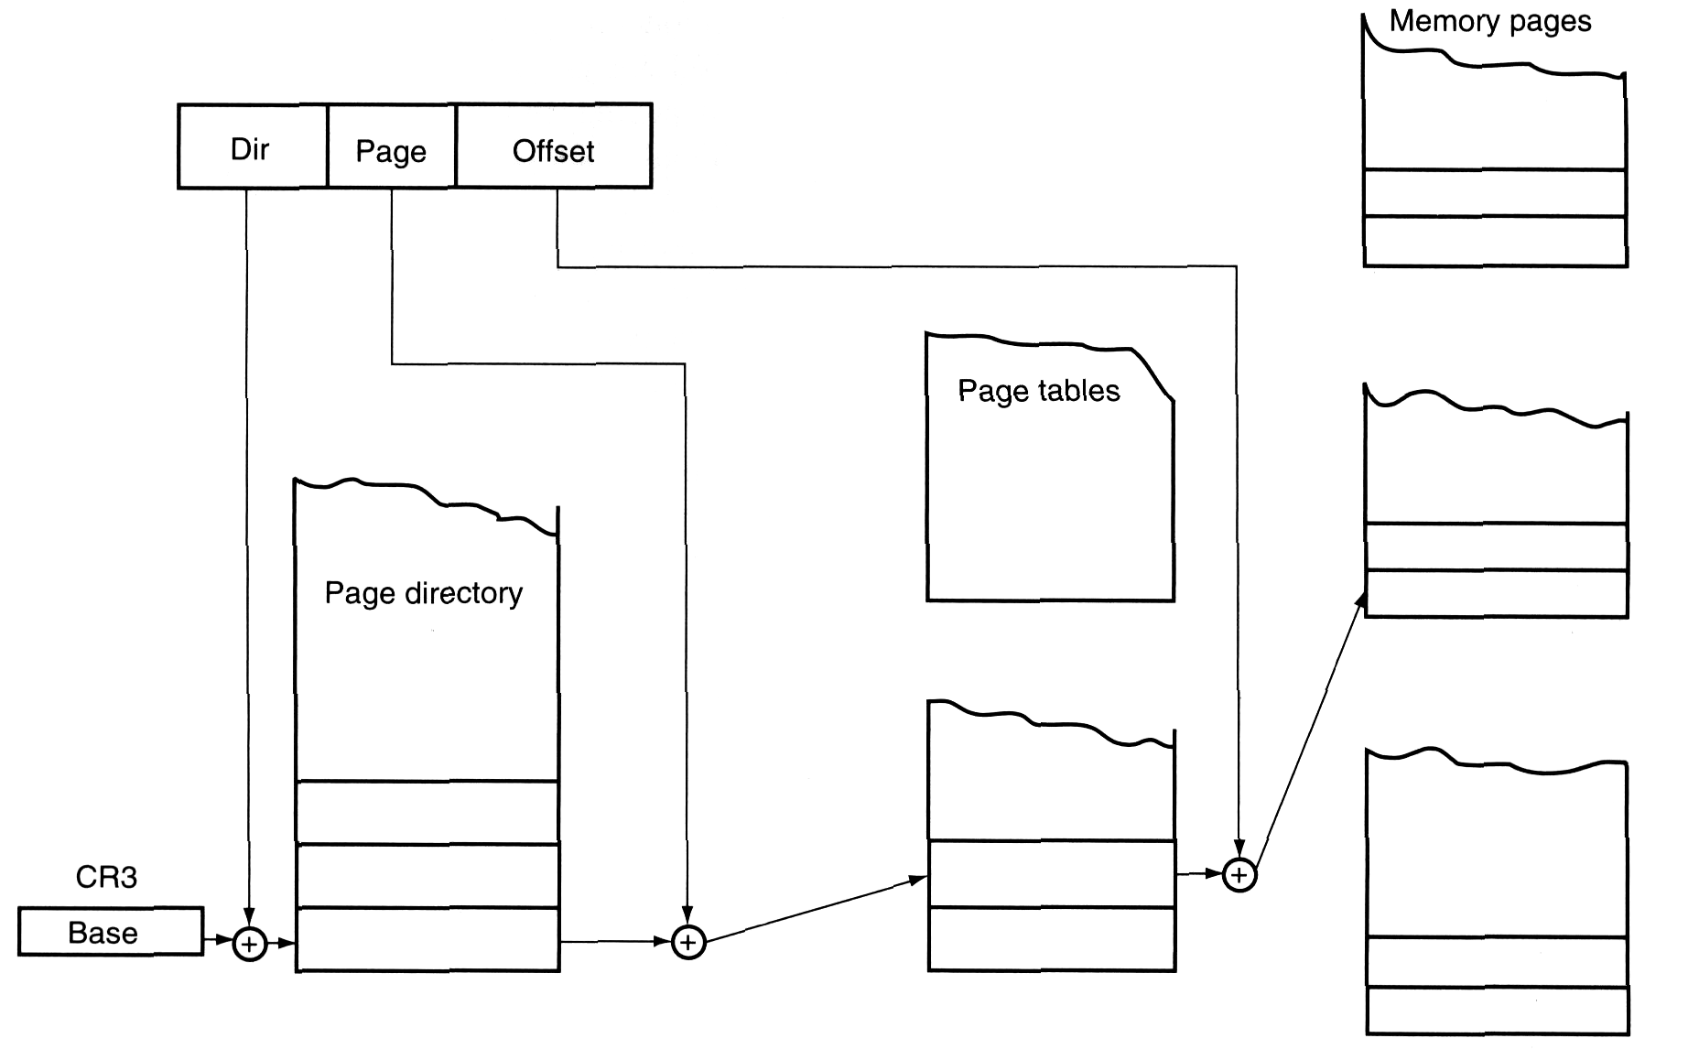
⊕：concatenate two parts into one
10bit
entry
12bit
32-bit linear address
10bit
10bit
30bit
20bit
30bit pointer A
20bit
12bit
32-bit physical address
0f0e0d0cH
11223344H
entry
10bit
30bit pointer B
==============================================================================
【答案】:
The following figure shows the process to convert 32-bit linear address to 32-bit physical address. Suppose CR3=3ab82H, 32-bit linear address=03a28fd4H=03H,1010B,28H,fd4H, , please fill blanks below.
(1). 10-bit dir=0000 0011 10B, 10-bit page=10 0010 1000B, 12-bit offset= 0fd4 H. Here “dir”， “page” and “offset” are 3 parts of linear address.
(2). The pointer A is a 30-bit page directory entry pointer, and it points to a 32-bit entry 0f0e0d0cH. The 32-bit pointer A1 is obtained by concatenate pointer A and 2-bit 00, then pointer A1 = 3ab82 038 H =0011 1010 1011 1000
(3). The pointer B is a 30-bit page entry pointer, , and it points to a 32-bit entry 11223344H. The 32-bit pointer B1 is obtained by concatenate pointer B and 2-bit 00, then pointer B1 = 0f0e08a0 H;
(4). 32-bit physical address = 11223fd4 H;

- (12 points) The following program runs under 32-bit Visual C++ environment, each integer takes 32 bits.
The function cube() reads a character ch1. If ch1 is between ‘0’ to ‘9’, it is converted to a number between 0 to 9, then the cube of the number is obtained and returned as the return value of cube(); Otherwise, -1 of EAX is returned as the return value of cube(). Please fill the blanks to fulfill the above function.
// Integer array table1[10] contains cube of n where n is 0 to 9.
int table1[10]={0,1,8,27,64,125,216,343,512,729};
int cube()
{ int ch1;
ch1=_getche(); // read a character from keyboard and return it to ch1
_asm {
(1)
(2)
jb chr1
(3)
ja chr1
sub al, 30h
(4)
(5) ;
mov bl, al
mov eax, table1[ebx]
jmp end1
chr1: (6)
jmp end1
}
end1:;
}

==============================================================================
【答案】
(1) mov eax, ch1；mov al, ch1也算对，本行与下行互换也对
(2) cmp al, '0'
jb chr1
(3) cmp al, '9'
ja chr1
sub al, 30h
(4) shl al, 2 ; sal al,2也对
(5) xor ebx, ebx ; sub ebx, ebx 也对; mov ebx,0也对
mov bl, al
mov eax, table1[ebx]
jmp end1
chr1: (6) mov eax, -1

- (10 points) The following partial program multiplies each 4-byte element of array data1 by each 4-byte element of array data2, and stores the product into 8-byte element of array result, i.e. result[i]=data1[i]*data2[i]. Each arrays has 10 elements, and the multiplication repeats for 10 times. Please fill the blanks to fulfill the above target.
.data
data1 dd 10 dup(?)
data2 dd 10 dup(?)
result dq 10 dup(?)
.code
……

loop1:
mul data2[ebx*4]

mov dword ptr result[ebx*8+4],edx

loop loop1
……
==============================================================================
【答案】
xor ebx,ebx
mov cx,10
loop1: mov eax, data1[ebx*4]
mul data2[ebx*4]
mov dword ptr result[ebx*8],eax
mov dword ptr result[ebx*8+4],edx
inc ebx
loop loop1

===============================================

- (16 points) A 16550 chip is used in a x86 PC’s I/O extended card. Suppose its I/O base addresses are 0D0-0D7H and its pins A0,A1,A2 connect to system address bus A0,A1,A2. The following program initializes the 16550, Please fill appropriate value into each blank according to the prompt beside instruction.

MOV AL， B ；enable Baud divisor registers
OUT 0D3H，AL
MOV AL, ；set Baud rate to 57600
OUT 0D0H，AL
MOV AL，
OUT 0D1H，AL
; (5 points, fill 0 or 1 in each blank below)
MOV AL，000 B ；set line control register: 8-bit-data, even parity, one stop bit
OUT 0D3H，AL
MOV AL，00000111B ；enable transmitter and receiver
OUT 0D2H，AL
; (4 points, fill 0 or 1 in each blank below)
MOV AL, 0000 B ; enable transmitter interrupt and receiver interrupt, the latter
OUT , AL ; is only correct character receipt interrupts.
; (2 points, fill 0 or 1 in each blank below)
MOV AL, 000000 B ; enable /DTR and /RTS pin of 16550
OUT , AL
==============================================================================
【答案】
MOV AL，1XXX XXXXB ；enable Baud divisor registers
OUT 0D3H，AL
MOV AL, 20 ；set Baud rate to 57600
OUT 0D0H，AL
MOV AL，0
OUT 0D1H，AL
; (5 points, fill 0 or 1 in each blank below)
MOV AL，000 1 1 0 1 1 B ；set line control register: 8-bit-data, even parity, one stop bit
OUT 0D3H，AL
MOV AL，00000111B ；enable transmitter and receiver
OUT 0D2H，AL
; (4 points, fill 0 or 1 in each blank below)
MOV AL, 0000 0 X 1 1 B ; enable transmitter interrupt and receiver interrupt, the latter
OUT 0D1H, AL ; is only correct character receipt interrupts.
; (2 points, fill 0 or 1 in each blank below)
MOV AL, 000000 1 1 B ; enable /DTR and /RTS pin of 16550
OUT 0D4H, AL

==============================================================================

- （20 points）A 82C55 parallel communication adapter is designed as a PC’s extended card which is inserted in PCI bus slot. PC-1 uses 82C55-1 of its adapter to exchange 8-bit data with 82C55-2 of PC-2. PC-1 and 82C55-1 work symmetrically with 82C55-2 and PC-2, and this is displayed in the following figure. Each 82C55’s port A works for mode 0 output, while its port B works for mode 1 strobe input. Port A of each 82C55 sends 8-bit data to Port B of the other side. Pin PC0 of each 82C55 will generate a interrupt after it receives 8-bit data, and the interrupt subroutine RECV_82C55_INT receives the 8-bit data.
The slave 8259A of PC connects the PC0 of 82C55, its pin A0 connects to the A0 of system address bus and its I/O address is 0A0—0A1H; The I/O addresses of 82C55’s port A, B, C and command register are 300H, 301H, 302H,303H, respectively;
Procedure STORE_BUFFER stores AL into the receiving buffer, and don’t affect any register’s value. When it exits, it sets the ZF to 1 to indicate that the buffer is full, or it sets the ZF to 0 to indicate that the buffer is not full, The detailed instructions in STORE_BUFFER is not provided in this exam paper.
Procedure SEND has a 8-bit entry parameter in AL and it sends the data in AL. It first polls the status of 82C55’s PC3 which connects to the IBF pin of the opposite 82C55. Only when the opposite 82C55’s INPUT BUFFER is not FULL, the procedure SEND will send out the data and then outputs a negative pulse in this 82C55’s PC4 .
Notice: each comment usually prompts the function of instructions near the comment. One blank takes one point of score if score is not marked beside the blank.

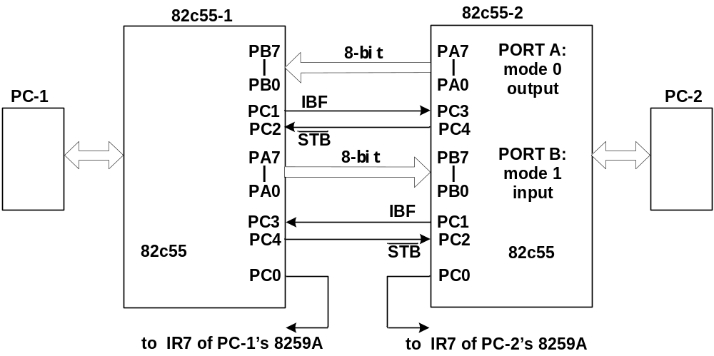

PORT_A EQU 300H
PORT_B EQU 301H
PORT_C EQU 302H
PORT_CMD EQU 303H
PIC1 EQU 0A0H
PIC2 EQU 0A1H

SIGNAL_EOI MACRO ; signal EOI (End of Interrupt) to slave 8259A

OUT PIC1, AL
ENDM

; SET_STB uses 8255's command byte B to set PC4 (/STB) to val (0 or 1)
SET_STB MACRO VAL ; Here the parameter val must be 0 or 1

MOV AL, VAL ; Constant expression may be used here.

ENDM
;The Procedure INIT_82C55 sets 82C55 command byte A: port A – mode 0 output,
; port B – mode 1 input, PC0 to PC3 – input; PC4 to PC7 -- output
INIT_82C55 PROC NEAR
MOV AL, B ; fill 0 or 1 in each blank, (4 points)

SET_STB 1 ; set /STB to 1 (inactive)
STI
RET
INIT_82C55 ENDP

SEND PROC NEAR
PUSH AX
LOOP1:
IN AL, DX

JNZ LOOP1 ; if IBF=1, go to LOOP1 to continue test

MOV DX, PORT_A ; output AL from port A

; to output a negative pulse
MOV CX, 8
LOOP2: LOOP LOOP2
SET_STB 1 ; set /STB to 1 (inactive)
RET
SEND ENDP

RECV_82C55_INT PROC FAR USES AX DX
; receive data

CALL STORE_BUFFER ; store AL into the receiving buffer
JNZ L2 ; if the receiving buffer is full, the CPU will mask 8259's IR7.
; The mask status of IR0—IR6 will not be affected.

OUT PIC2, AL
L2:
IRET
RECV_82C55_INT ENDP

==============================================================================
【答案】
PORT_A EQU 300H
PORT_B EQU 301H
PORT_C EQU 302H
PORT_CMD EQU 303H
PIC1 EQU 0A0H
PIC2 EQU 0A1H
.MODEL SMALL
.STACK 1024
.CODE
.STARTUP
MOV AL,41H
CALL SEND
.EXIT

SIGNAL_EOI MACRO ; signal EOI (End of Interrupt) to 8259A
MOV AL, 20H ; 20H写成 xx100xxx B的值也对；
OUT PIC1, AL
ENDM

SET_STB MACRO VAL ; Here the parameter val must be 0 or 1
; Use 8255's command byte to set PC4 (/STB) to val (1 or 0)
MOV DX, PORT_CMD
MOV AL, 0XXX 1000B OR VAL ; Constant expression may be used here.
OUT DX, AL ; OR改成+、xor也对
ENDM
;The Procedure INIT_82C55 sets 82C55 command byte A: port A – mode 0 output,
; port B – mode 1 input, PC0 to PC3 – input; PC4 to PC7 -- output
INIT_82C55 PROC NEAR
MOV AL, 1 0 0 0 0 1 1 1B ; fill 0 or 1 in each blank, (4 points)
MOV DX, PORT_CMD
OUT DX, AL
SET_STB 1 ; set /STB to 1 (inactive)
STI
RET
INIT_82C55 ENDP

SEND PROC NEAR
PUSH AX
LOOP1: MOV DX, PORT_C
IN AL, DX
TEST AL, 00001000B ; and AL, 00001000B也对
JNZ LOOP1 ; if IBF=1, go to LOOP1 to continue test
POP AX
MOV DX, PORT_A ; output AL from port A
OUT DX, AL
SET_STB 0 ; to output a negative pulse
MOV CX, 8
LOOP2: MOV AX, AX
LOOP LOOP2
SET_STB 1 ; set /STB to 1 (inactive)
RET
SEND ENDP

RECV_82C55_INT PROC FAR USES AX DX
MOV DX, PORT_B ; receive data
IN AL, DX
CALL STORE_BUFFER ; store AL into the receiving buffer
JNZ L2 ; if the receiving buffer is full, the CPU will mask 8259's IR7.
IN AL, PIC2 ; The mask status of IR0—IR6 will not be affected.
OR AL, 80H ; MOV AL, 80H; 也算对
OUT PIC2, AL ; PIC2必须小于FFH，否则要用DX
L2: SIGNAL_EOI
IRET
RECV_82C55_INT ENDP

==============================================================================

